|  |  |
| --- | --- |
| **Register No:** | **99220040570** |
| **Name** | **KAPILAVAI HANUMAAN** |
| **Class/Section** | **8501A/S06** |
| **Ex.No:** | **5a** |
| **Date of Submission** | **30.1.2025** |
| **Name of the Experiment** | **Configuration of Inter VLAN network using L3 switch** |
| **Google Drive link of the packet tracer file**  **(give view permission):** | **https://drive.google.com/drive/folders/1I_8ZkmO7MM-Ldjr6i418KiKQMEP8Gnb0?usp=drive_link** |

**Objective(s):**

To design and implement Inter VLAN using switch configuration

**Introduction:**

Normally, Routers are used to divide the broadcast domain and switches (at layer 2) Operate in a single broadcast domain but Switches can also divide the broadcast domain by using the concept of **VLAN (Virtual LAN)**.

**VLAN** is the logical grouping of devices in the same or different broadcast domains. By default, all the switch ports are in VLAN 1. As the single broadcast domain is divided into multiple broadcast domains, Routers or layer 3 switches are used for intercommunication between the different VLANs.The process of intercommunication of the different Vlans is known as Inter Vlan Routing (IVR).

Suppose we have made 2 logical groups of devices (VLAN) named sales and finance. If a device in the sales department wants to communicate with a device in the finance department, inter-VLAN routing has to be performed. These can be performed by either router or layer 3 switches.

**Switch Virtual Interface (SVI):** SVI is a logical interface on a multilayer switch that provides layer 3 processing for packets to all switch ports associated with that VLAN. A single SVI can be created for a VLAN. SVI on the layer 3 switch provides both management and routing services while SVI on layer 2 switch provides only management services like creating VLANs or telnet/SSH services.

**Process of Inter Vlan Routing by Layer 3 Switch:** The SVI created for the respective VLAN acts as a default gateway for that VLAN just like the sub-interface of the router (in the process of Router On a stick). If the packet is to be delivered to different VLANs i.e inter VLAN Routing is to be performed on the layer 3 switch then first the packet is delivered to the layer 3 switch and then to the destination just like in the process of the router on a stick.

1. **Device Requirements:**

1.L3 Switch

1. PC0

3.PC1

4.PC2

5.PC3

6.Cable

7. Switch 0

8.Switch 1

1. **Network Diagram for your experiment (draw the diagram either hand drawing/ms paint or any other drawing tools)**

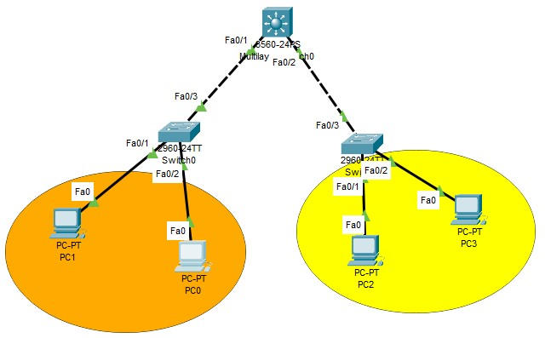

1. **Network Diagram (Packet Tracer diagram before configuration):**

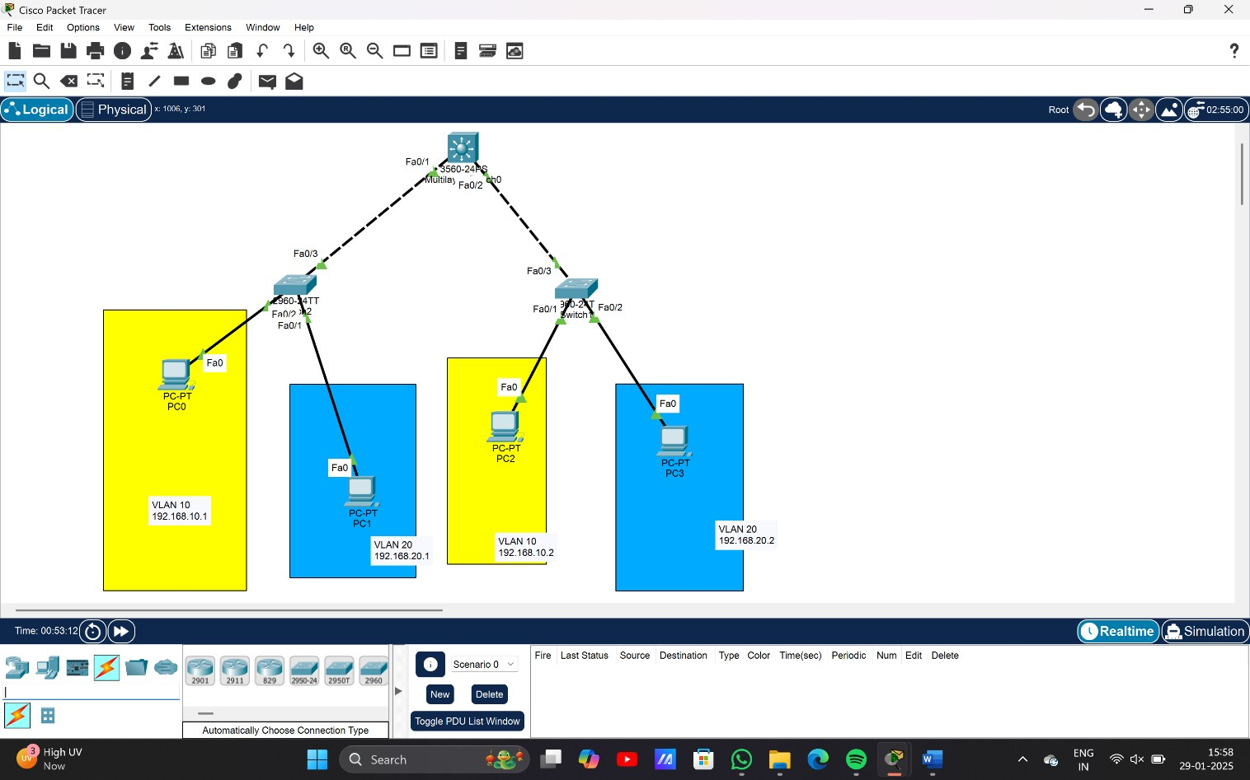

1. **Configuration details:**

|  |  |  |  |
| --- | --- | --- | --- |
| **Device Name** | **Interface Name** | **IP Address** | **Subnet mask** |
| PC0 | Fa0/2 | 192.168.10.1 | 255.255.255.0 |
| PC1 | Fa0/1 | 192.168.20.2 | 255.255.255.0 |
| PC2 | Fa0/1 | 192.168.10.2 | 255.255.255.0 |
| PC3 | Fa0/2 | 192.168.20.2 | 255.255.255.0 |
| Switch 0 | Fa0/1 |  |  |
| Switch 1 | Fa0/2 |  |  |
| L3 switch |  |  |  |

1. **Describe step by step configuration steps properly (you may copy the commands used in the configuration tab and paste it.)**

**1.Create VLANs**

**2.Configure interfaces**

**3. Configure trunking**

1. **Output Diagram (Minimum 3 screenshot):**

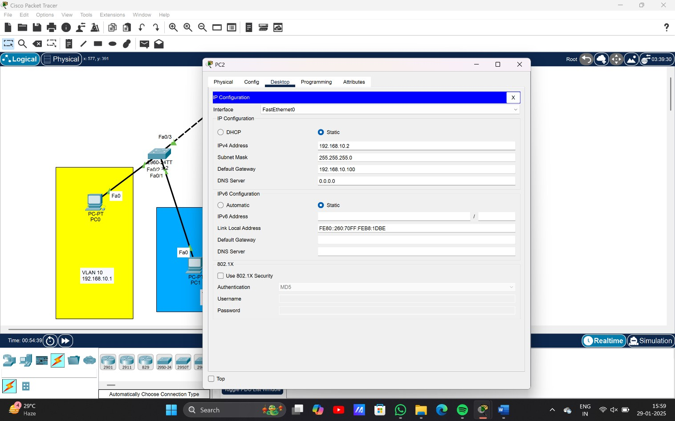

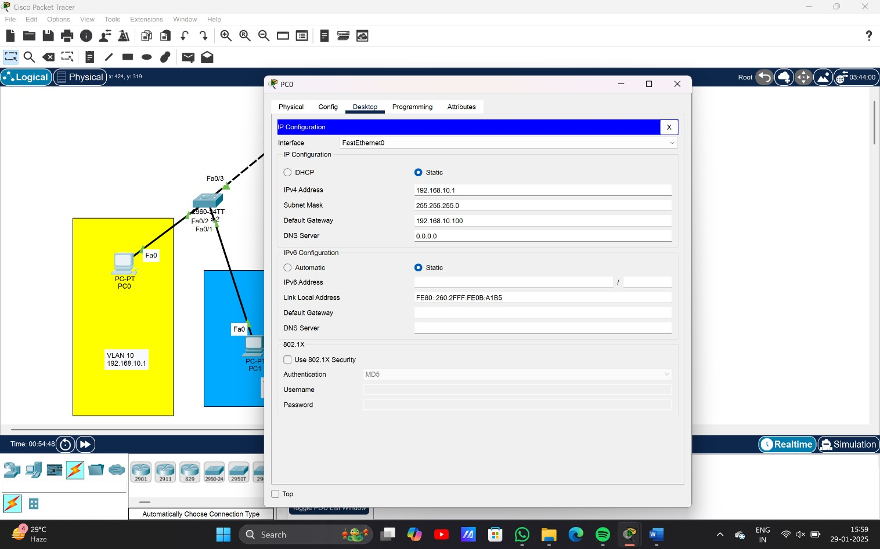

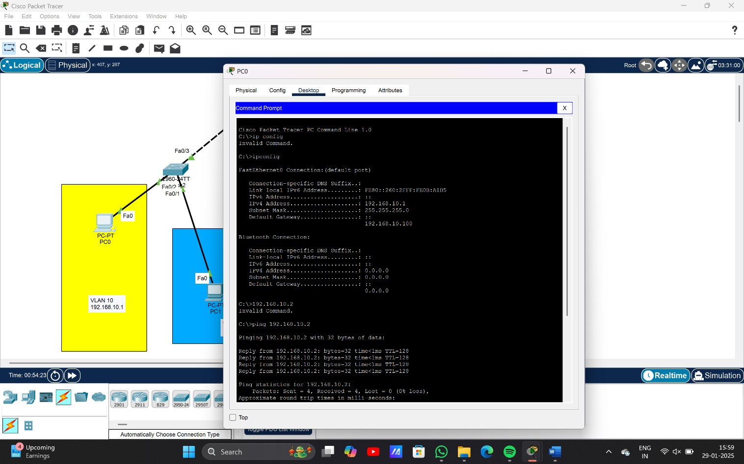

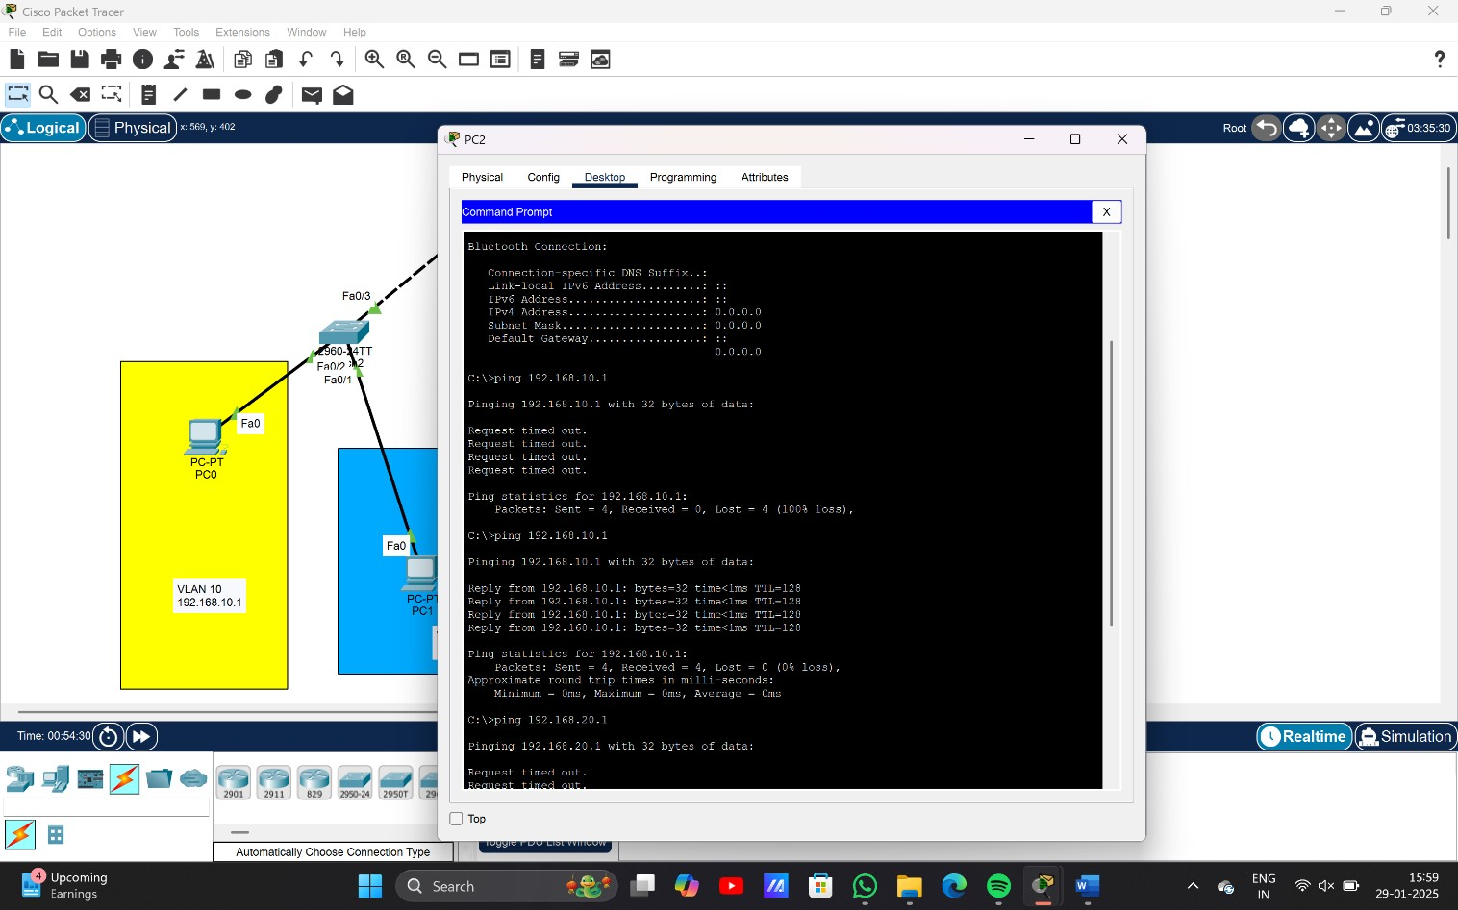

**Rubrics for Experiment Assessment:**

|  |  |  |  |  |
| --- | --- | --- | --- | --- |
| **Rubrics** | **Good** | **Normal** | **Poor** | **Marks** |
| **Creation of Topology (4)** | Created the topology, Identify the proper devices and making the  connections **(4)** | Created the topology, Identify the proper devices, making the connections But missing some features **(3)** | Created wrong topology, Failed to Identify the proper devices and making connections **(1)** |  |
| **Verify the connectivity**  **(4)** | Verified the connectivity in all the levels **(4)** | Verified the connectivity at some levels (only some nodes) **(2)** | Verified the connectivity is not done. **(1)** |  |
| **Timely**  **Completion**  **(2)** | Completed the lab before the allotted time **(2)** | Completed the lab after the deadline **(1)** | Did not submitted  before grading **(0)** |  |
|  |  |  | **Tota**l |  |

**RESULT:** The Configuration